http://www.slu.edu/1818

ENGL 1900 - Advanced Strategies of Rhetoric and Research

Hillsboro High School
English 102

Course Syllabus

Semester: Spring 2017-18

Instructor: Elizabeth Gonzalez

Contact Information:
bgonzalez@hillsboroschools.net
(217) 532-2841
Monday-Friday

Text/Resources Information:
Cohen, 50 Essays: A Portable Anthology (4th Ed.)
Ede, The Academic Writer (3rd Ed.)
Ramage, Bean, and Johnson, Writing Arguments: A Rhetoric with Readings (Concise 6th Ed.)
Orwell, 1984
Supplemental texts TBD

Course Description:
Prerequisite: ENGL 1500 or its equivalent. Studies complex structures of language, including its logical and persuasive possibilities. Emphasizes analytical reading, critical thinking, and research methodology skills.

Course Learning Objectives/Goals:
Students who complete this course will be able to:
- Write and design persuasive messages that incorporate various kinds of research in order to appeal to specific rhetorical situations (i.e., purposes, audiences, and contexts).
- Compose rhetorically appropriate prose and design that meets audience expectations of style, usage, and other conventions.
- Analyze rhetorical situations and messages by using a sophisticated conceptual vocabulary.
- Incorporate rhetorically appropriate and reliable research sources into new compositions.
- Summarize, paraphrase, and quote texts accurately and fairly.
- Evaluate their own compositions and rhetorical choices.

Method for Determining Final Grade for Course:
- Reading, analyzing, and discussing assigned texts
- Active participation in collaborative scenarios (composition and revision processes)
- Producing a minimum of three formal essays
- Oral and multimedia compositions/presentations
- Shorter, focused writing and research exercises
- Final Exam

Course Grading Scale:
- 93-100 A
- 83-92 B
- 73-82 C
- 63-72 D
- 62-⬇ F

SLU Grading Information:
Unless otherwise presented in this section, Saint Louis University has reviewed and approved the above course grading scale to be used by the instructor for the transcripted Saint Louis University college grade.

Saint Louis University’s undergraduate grading system follows a 0 - 4.000 grade point scale. Grades are assigned to the SLU transcript as follows:
Grade | Grade Points | Interpretation
A | 4.000 | High achievement and intellectual initiative
A- | 3.700
B+ | 3.300 | Above average, approaching high achievement
B | 3.000 | Above average achievement
B- | 2.700
C+ | 2.300 | Midway between B and C
C | 2.000 | Average achievement
C- | 1.700
D | 1.000 | Inferior but passing achievement
F | 0 | Failure

Note on SLU Undergraduate Cumulative GPA:
The grades earned through the 1818 Advanced College Credit Program are considered Saint Louis University grades, and will become part of the student's undergraduate GPA if the student enrolls at Saint Louis University as a full time student.

Significant Learning Activities / Evaluation Strategies and Approximate Deadlines and/or Calendar:

- Moving Your Audience (Writing Arguments, Ch. 6) Ethos, Pathos, and Kairos; Multimodal treatment: enhancing previous argument with effective photography/images (revision of piece with this focus). (1-2 weeks)
- Responding to Objections and Alternative Views (WA Ch. 7); Claim and concession/rebuttal (1 week)
- Analyzing and Deconstructing Arguments; Questions for Rhetorical Analysis; models and responses (WA Ch.8); (2-3 weeks)
- Analyzing and Constructing Visual Arguments (WA Ch. 9); Visual argument construction and presentation (student choice for media) (1-2 weeks)
- Types of Claims overview (WA Ch. 10); Focus on Causal, Evaluation and Proposal claims (WA Ch. 13 and 14); Research outline for each; student choice for claim style used in formal essay (approx. 4-5weeks)
- Study of Orwell’s 1984; Research presentation (the effects of modern propaganda). (4-5 weeks)

Information Essential to Student Success in SLU Course:

Academic Integrity Syllabus Statement
Academic integrity is honest, truthful and responsible conduct in all academic endeavors. The mission of Saint Louis University is "the pursuit of truth for the greater glory of God and for the service of humanity." Accordingly, all acts of falsehood demean and compromise the corporate endeavors of teaching, research, health care, and community service via which SLU embodies its mission. The University strives to prepare students for lives of personal and professional integrity, and therefore regards all breaches of academic integrity as matters of serious concern.

The governing University-level Academic Integrity Policy was adopted in Spring 2015, and can be accessed on the Provost's Office website at:http://www.slu.edu/Documents/provost/academic_affairs/University-wide%20Academic%20Integrity%20Policy%20FINAL%20%206-26-15.pdf.

Additionally, each SLU College, School, and Center has adopted its own academic integrity policies, available on their respective websites. All SLU students are expected to know and abide by these policies, which detail definitions of violations, processes for reporting violations, sanctions, and appeals. Please direct questions about any facet of academic integrity to your faculty, the chair of the department of your academic program, or the Dean/Director of the College, School or Center in which your program is housed.

Students participating in the 1818 Advanced College Credit Program are held to and should be familiar with the College of Arts and Sciences Academic Honesty policy available at: http://www.slu.edu/college-of-arts-and-sciences-home/undergraduate-students/academic-honesty

SLU Disability Services Academic Accommodations
Students with a documented disability who wish to request academic accommodations must contact Disability Services to discuss accommodation requests and eligibility requirements. Once successfully registered, the student also must notify the course instructor that they wish to access accommodations in the course.

Please contact Disability Services, located within the Student Success Center, at Disability_services@slu.edu or 314.977.3484 to schedule an appointment. Confidentiality will be observed in all inquiries. Once approved, information about the student’s eligibility for academic accommodations will be shared with course instructors via email from Disability Services and viewed within Banner via the instructor’s course roster.

Note: Students who do not have a documented disability but who think they may have one are encouraged to contact to Disability Services.

SLU Student Success Center:
In recognition that people learn in a variety of ways and that learning is influenced by multiple factors (e.g., prior experience, study skills, learning disability), resources to support student success are available on campus. The Student Success Center, a one-stop shop, which assists students with academic and career related services, is located in the Busch Student Center (Suite, 331) and the School of Nursing (Suite, 114). Students who think they might benefit from these resources can find out more about:
- Course-level support (e.g., faculty member, departmental resources, etc.) by asking your course instructor.
- University-level support (e.g., tutoring services, university writing services, disability services, academic coaching, career services, and/or facets of curriculum planning) by visiting the Student Success Center or by going to www.slu.edu/success.

Saint Louis University Accreditation:
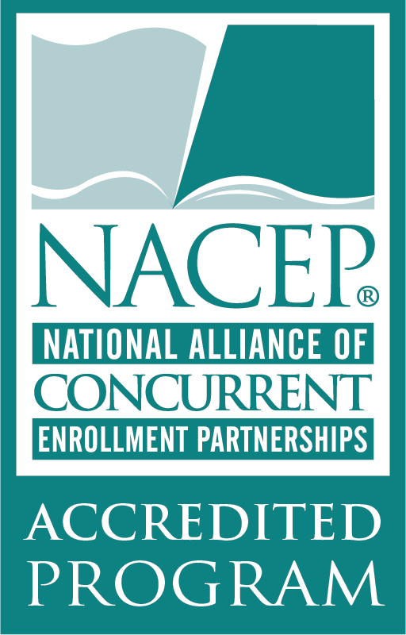
As an institution, Saint Louis University is fully accredited by the Higher Learning Commission (HLC). SLU has been continuously accredited since 1916.
Additionally, the 1818 Advanced College Credit Program is a founding and fully accredited institution of the National Alliance of Concurrent Enrollment Partnerships (NACEP) and, complies with both the Missouri Department of Higher Education’s Dual Credit Policy (MDHE), Illinois Board of Higher Education (IBHE) Dual Credit Task Force, Ohio College Credit Plus, Iowa Senior Plus, and State of Hawaii Dual Credit Policy.

