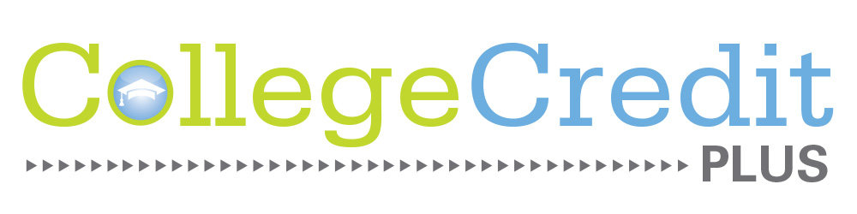
Archbold Area Schools
College Credit Plus
Self-Pay Agreement Form

State law allows a student to self-pay for a college course under the College Credit Plus program. Under such conditions, the student has the right to declare whether they wish to earn college credit only for the course or to earn both college and high school credit. Once a student declares their intention for credit earned, they cannot change that at a later date. Under Archbold Area Schools’ policy, remediation level courses cannot be taken for high school credit. Students who elect to receive high school credit will have the self-pay courses listed on the high school transcript and factored into the GPA.

Name of Self-Paid Course(s)

_____________________________________________ Term: __________________
College Credit Only College and High School Credit Remediation

_____________________________________________ Term: __________________
College Credit Only College and High School Credit Remediation

_____________________________________________ Term: __________________
College Credit Only College and High School Credit Remediation

I understand that by signing this form, I acknowledge that I am agreeing to pay for the above named courses and all related books and supplies and that Archbold Area Schools will not be financially responsible in any capacity. I understand I cannot change the credit option at a later date and that remediation courses must be taken for college credit only. I understand that any course I mark for high school credit will be added to my transcript and factored into my GPA.

___________________________ ____________________________ ___________
Student Name (printed) Student Signature Date

___________________________ ____________________________ ___________
Parent/Guardian Name (printed) Parent/Guardian Signature Date

